My small Teeswater flock are registered pedigrees and are kept on my family's Organic Farm in East Yorkshire.
Teeswater's are a longwool rare breed sheep native to Britain. The fleece has a lovely long fine curly staple with plenty of lustre.
I have the following fibres and fleece available:
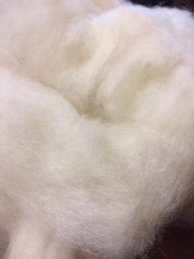
Teeswater fibre washed & carded
The fibre is washed & carded, so ready to be spun or used for felting or other crafts. It is all a natural colour so also ideal for dyeing as it tends to hold colour very well.
100g - £5 + P&P £3.50
250g - £12.50 + P&P £3.50
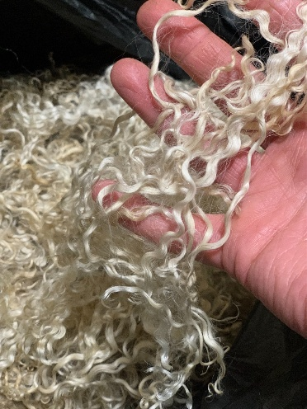
500g - £25 + P&P £5
1kg - £50 + P&P £5
Teeswater Lambswool Fleece
Autumn sheared lambswool – beautifully soft open fleece with a finer and slight shorter staple length. This is raw unwashed fleece and has some vegetation amongst it.
£15 - 500g + P&P £5
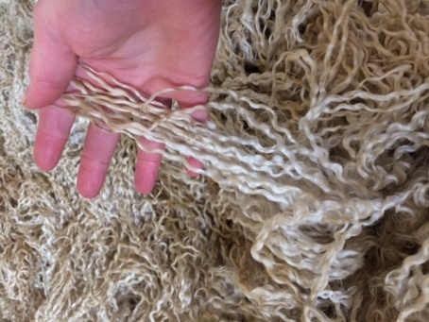
Teeswater Shearling Fleece
This fleece has the longest staple length – these are raw unwashed fleece. They have been well skirted and have minimal vegetation amongst them.
Alice - 4kg Teeswater Shearling Fleece
Ginger 4kg Teeswater shearling Fleece
Oreo 3kg Teeswater Shearling Fleece
£25 per kilo + P&P
I also have some 2 shear Teeswater fleece available – please ask me for details.

